E-Work Permit Contract Management User Manual



**Introduction**

**Dear Users,**

**Welcome to MonitPro E-Work Permit Contract Management User Manual**

Thank you for using MonitPro E-Work permit contract management for your factory. There are number of benefits for using MonitPro E-Work permit Contract Management System: Risk is identified easily, Job is authorized and informed to all the concerned people, Ensured that area is free of hazards, people get the required protection, work is closed safely, work area & Job duration is easily identified and save your time.

In this user manual, detailed information about MonitPro E-Work permit system Software functionalities and how Operator, engineers, managers can use the e-work permit system is given. We look forward to receive your feedback.

If you have any questions and suggestions, please write to: [monitpro@monitpro.in](mailto:monitpro@monitpro.in)

Thank you,

Team-MonitPro

**Table of Contents**

**1.** **Introduction** 4

**2.** **User Role** 4

**3.** **E-Work Permit User Interface** 5

3.1 Admin 5

3.2 Create Permit 6

3.3 Pending Approval 6

3.4 Approved 6

3.5 History 7

3.6 Contractor 7

**MonitPro User Manual**

# **Introduction**

MonitPro e-work permit contract management system provides how to create, approve the work permit, manage the contractor’s details and examine the contractors based on their work done in the digital platform. We completely eliminating the paper based work and we improve the work permit system as faster, easier, safer and efficient. Monitpro e-permit software is also collaborative tool for Work permit system & contractor management system. For more details visit our website [http://www.monitprosolutions.com](http://monitprosolutions.com)

For Desktop/Laptop view, MonitPro Web application can be effectively seen using **Google Chrome Browser**.

# **User Role**

A User can create the permit, view the permit, approve the permit, extend the permit and close the permit.

There are 3 roles and is described below:

**Admin role:**

Admin role has Administration privilege and will be able to create, edit and assign the user role. Also, an Admin Role will be able to add new user and provide Issuer/Approver/Admin access to the other users.

**Issuer role:**

Issuer role allows only to create the permit and submit the permit for an approval. In addition to that Issuer can print, extend and close the permit after the permit is approved from the approver.

**Approver role:**

Approver role allows to create the permit, submit, approve, print, close and review the closed permit with comments. But same user cannot create the permit and approve the permit.

# **E-Work Permit User Interface**

MonitPro E-work permit User Interface provides a user to create the main work permit, print & close the permit and also print the closed permit. The User Interface is classified into six sections as below:

1. Admin
2. Create Permit
3. Pending Approval
4. Approved
5. History
6. Contractor

Each of the above sections is described in detailed below:

## Admin

Only Admin privilege user will be able to view this page. During the Initial set up, a user will be given admin privilege. Admin section consists of two subsections:

**i. Create User ii. User List**

1. **Create User**

This option allows the Admin to create a new user. One should specify the First name, Last name, Valid Email, User role, Mobile number, designation, Username and Password.

Users have an access to create the permit and close the permit. Only admin user have an access to add contractor details. Depending on the level of access the user can view, edit and provide access to the other users.

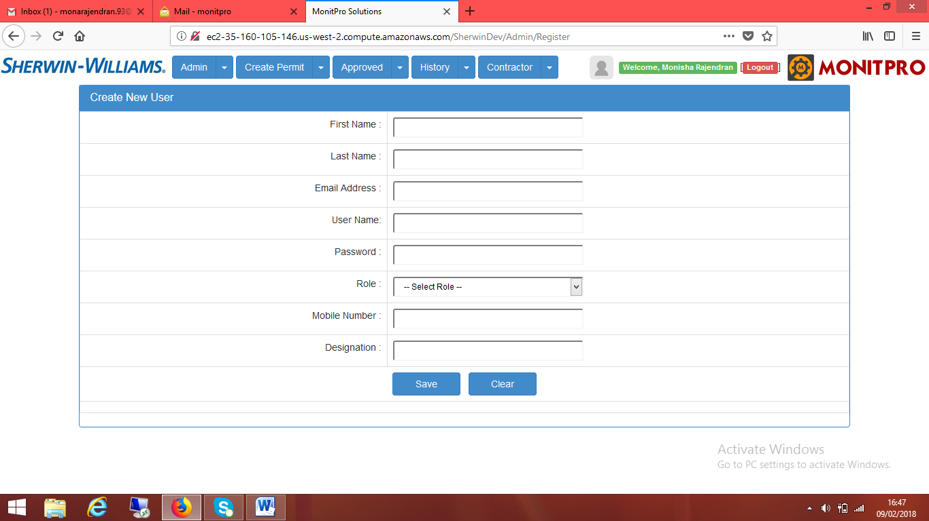

1. **User List**

User list displays the entire list of users and their details. The edit option allows to edit the User information and to include the picture of the user. A user can be deactivated by means of un-checking the active button.

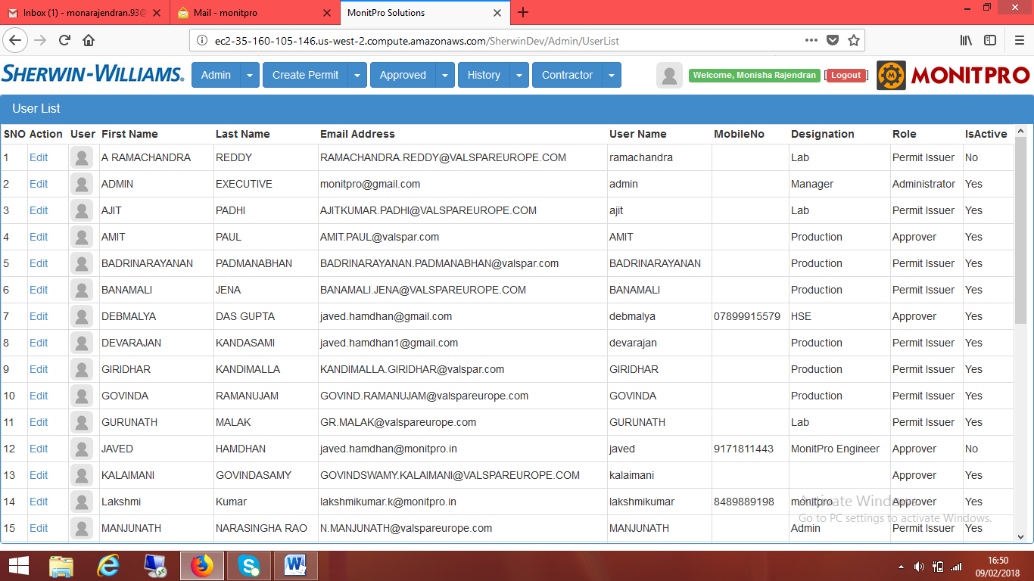

1. **Assign Type Of Work**

Admin privilege user can assign work type to the approver. The type of work which is assigned by the admin will be displayed under approver name dropdown list box of Create new permit page.

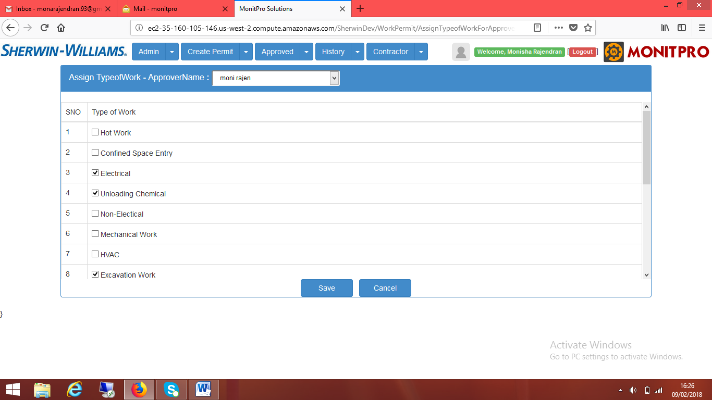

## Create Permit

In create permit section user can allow to create the permit. Create permit consist of two subsections **i. New Permit and ii. My Permit List**

1. **New Permit**

This option allows to creating the new permit with valid from and to date& time, Location, Equipment name, Contractor, Type of work, Description of work, Risk assessment required, Fire watch required, Personal Protective Equipment, Permit holder, No of person at site, Adjacent area owner, Approver and sub checklist (If we choose Type of work as Hot work, Electrical, Confined Space entry, Working at height or fragile roof, Excavation Work, Line Breaking, Lockout Tagout and Unloading Chemical is shown in below the main permit). The permit will be saved as draft.

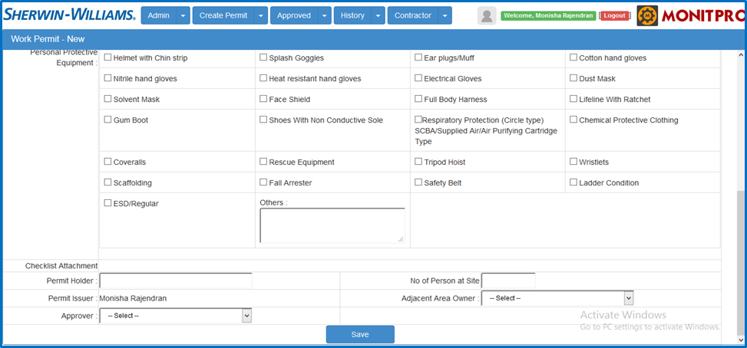

1. **My Permit List**

This option allows the user to check the work permit form as a draft. To click the edit button of the permit, after that all the fields in the permit are editable. Pdf option will used to preview and downloaded the created permit including checklist. In Attach option user can attach the scanned copy and submit for the approval. If the permit is rejected by the approver, the rejected permit can be seen through the “My Permit list” with the approver comments.

## Pending Approval

* + 1. **Pending Approval List**

This option is access for Approver user only to approve the work permit. Click the review button and the approver should enter their comments in the work permit. By clicking checklist attachment button approver can download and view the work permit scanned copy. If all the information in the permit are correct select **“Approve”** or any of the information is incorrect select **“Reject”**.

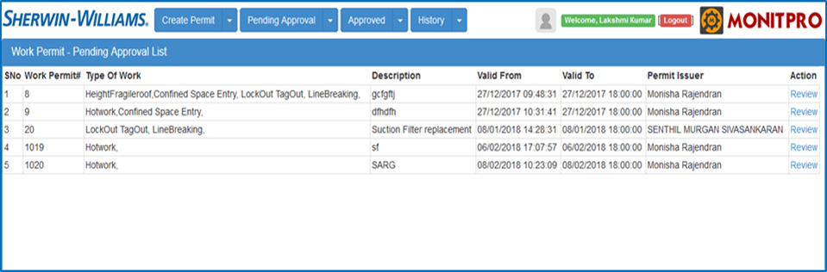

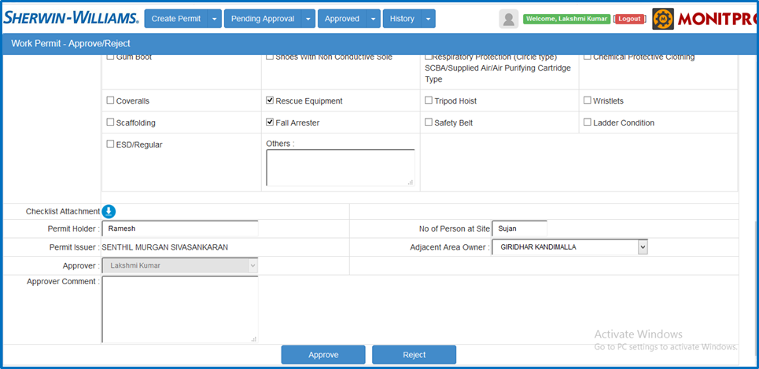

* + 1. **Review Closed Permit**

Review closed permit is shown only for approver according to the due date to review the entire closed work permit. User should enter their comments and complete the task with attachments. It is display in the history page of reviewer comments including completed date time, action comments, completed by and attachments.

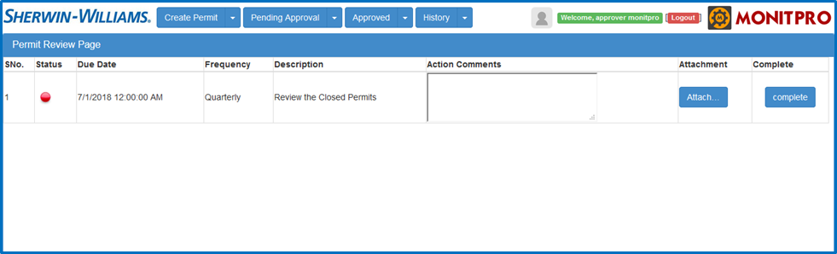

## Approved

* + 1. **Approved Permit List**

This options allows the user to Print/Close the permit. Print permit is an option to print the approved permit. An attachment option is provide to attach and save a scanned copy of approved work permit. User restricted by three types of authorization to close the work permit:

* Without attachment user cannot able to close the permit.
* Only assigned type of work approver can close the work permit.
* Permit issuer cannot able to close the permit even though he/she is an approver.

Close permit is an option after work is completed the user can give their comments and rating (Red/Yellow/Green) for the contractor based on their work.

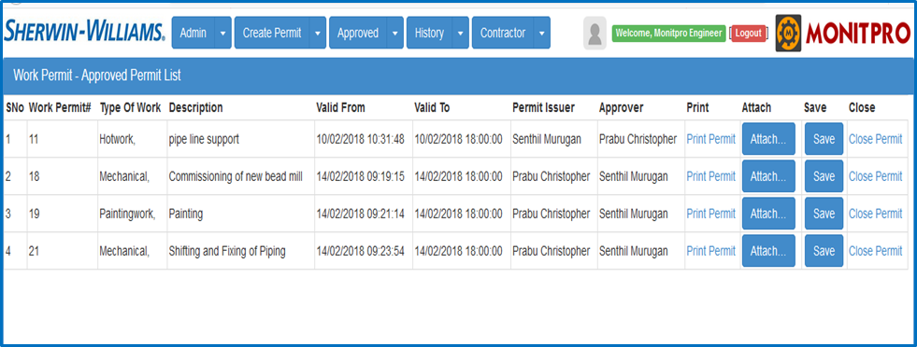

## History

* + 1. **Closed Permit List**

This option allow the user to View the closed permit. To click the action button it automatically download work permit as PDF. By clicking export closed list link user can downloaded the closed list as an excel format.

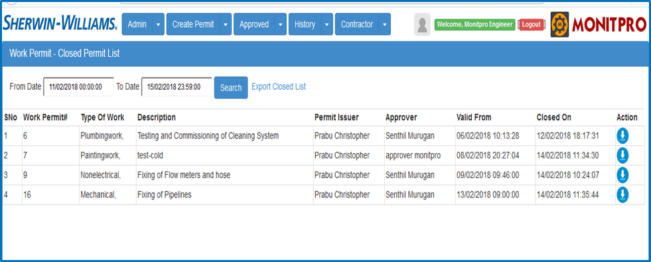

## Contractor

In contractor section Admin user can allow to create contractor details. Contractor have two sections **i. Contractor Assessment Form and**

**ii. Contractor List iii. Contractor rating**

1. **Contractor Assessment Form**

This option is allow to enter the contractor details like Company name, Supervisor First name & Last name, Address, Street, City, State, Country, Post code, Email address, Mobile no, Nature of business(dropdown list), Certification

1. **Contractor List**

Contractor list displays the entire list of Contractors and their details. The edit option allows to edit the Contractor information. A Contractor can be deactivated by means of un-checking the active button.